IMMUNOLOGY
Topic for – Paper-PHYG, SEC-A1 (Microbiology and Immunology)
Nadim Haider, Assistant Professor and HOD, Department of Physiology,
Netaji Nagar Day College, Kolkata-700092, West Bengal

Introduction:
Immunology is the branch of biological science which deals with the study of the immune system, which is the body's defense mechanism against pathogens.
These pathogens include viruses, bacteria, fungi, and parasites. The immune system is complex and involves many different types of cells, molecules, and processes that work together to provide defense to the body from infection and disease.
Immunity is the ability of the body to defend itself against disease-causing organisms.
Types of Immunity:
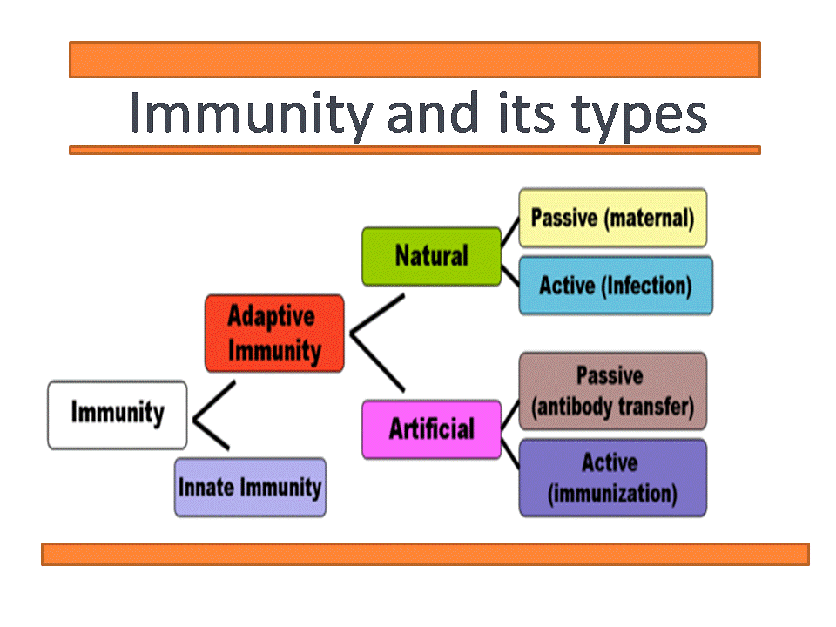
There are two major types of immunity: innate or natural or nonspecific and acquired or adaptive immunity.
1. Innate immunity is inherited by the organism from the parents and protects it from birth throughout life. For example, humans have innate immunity against distemper, a fatal disease of dogs.
2. The immunity that an individual acquires after the birth is called Acquired immunity or adaptive immunity. It is specific and mediated by antibodies or lymphocytes or both which make the antigen harmless.
Immunity can also be described as either active or passive, depending on how it is acquired:
- Active immunity involves the production of antibodies by the body itself and the subsequent development of memory cells
- Passive immunity results from the acquisition of antibodies from another source and hence memory cells are not developed
Active immunity will result in long-term immunity but passive immunity will not (due to the presence or absence of memory cells)
- Both active and passive immunity can be induced by either natural or artificial mechanisms
Examples of Active Immunity
- Natural – Producing antibodies in response to exposure to a pathogenic infection (i.e. challenge and response)
- Artificial – Producing antibodies in response to the controlled exposure to an attenuated pathogen (i.e. vaccination)
Examples of Passive Immunity
- Natural – Receiving antibodies from another organism (e.g. to the foetus via the colostrum or a new born via breast milk)
- Artificial – Receiving manufactured antibodies via external delivery (e.g blood transfusions of monoclonal antibodies)

The Immune System: 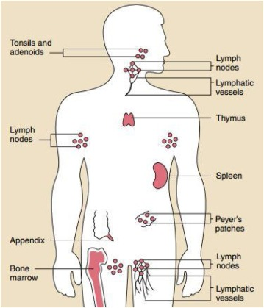
The immune system is present in almost all parts of the human body. It is usually composed of two main types of cells i.e the innate immune cells and the adaptive immune cells. Innate immune cells form the first line of defense against pathogens and are present since birth.They include phagocytes, such as macrophages, Natural killer (NK) cells and neutrophils, which engulf and digest foreign microorganisms. Natural killer (NK) cells can also directly kill infected or cancerous cells.
The adaptive immune cells, on the other hand, are activated after exposure to foreign invaders and provide long-term protection against specific pathogens. Adaptive immune cells include T- cells, which recognize and kill infected cells, and B- cells, which produce antibodies that can bind to and neutralize pathogens through complementary action.
Immune Response:
The immune response is the series of steps that occur when the body is exposed to a pathogen. The first step of immune response is the recognition of the pathogen by the immune system. This can occur through the detection of pathogen-associated molecular patterns (PAMPs) by pattern recognition receptors (PRRs) on innate immune cells.
The recognition of PAMPs by PRRs leads to the activation of innate immune cells, which release cytokines that recruit other immune cells to the site of infection. Phagocytes also engulf and digest the pathogen.
If the innate immune response is not sufficient to clear the infection, the adaptive immune response is activated. T cells and B cells recognize specific antigens on the surface of the pathogen. Antigens are molecules that stimulate an immune response by binding to receptors on immune cells.
Once T cells and B cells recognize the antigen, they become activated and undergo clonal expansion, which results in the production of many identical cells that can specifically recognize and respond to the pathogen. T cells can directly kill infected cells, while B cells produce antibodies that bind to the pathogen and neutralize it.
The immune response is regulated by a complex network of molecules and cells that prevent over activation or inappropriate activation of the immune system. Supressor T cells are a type of T cell that can suppress the activation of other T cells, while cytokines such as interleukin-10 (IL-10) can also inhibit the immune response.
Structure of an antibody:
Antibodies are the specific glycoproteins (Immunoglobulin) produced by cells in response to stimulation by an antigen and capable of reacting specifically with that antigen. Every immunoglobulin ( Ig) has the same basic structure made up of four polypeptide chains (two heavy chains and two light chains).These chains are held together by non-covalent forces and covalent disulphide bridges.Both the H-chain and L-chain can be divided into two regions based on variability in the amino acid sequences.
1) Light Chain: Variable region, V_{L} (110 amino acids) and constant region, C_{L} (110 amino acids)
2) Heavy Chain: Variable region, V_{H} (110 amino acids) and constant region, C_{H} (330-440 amino acids).
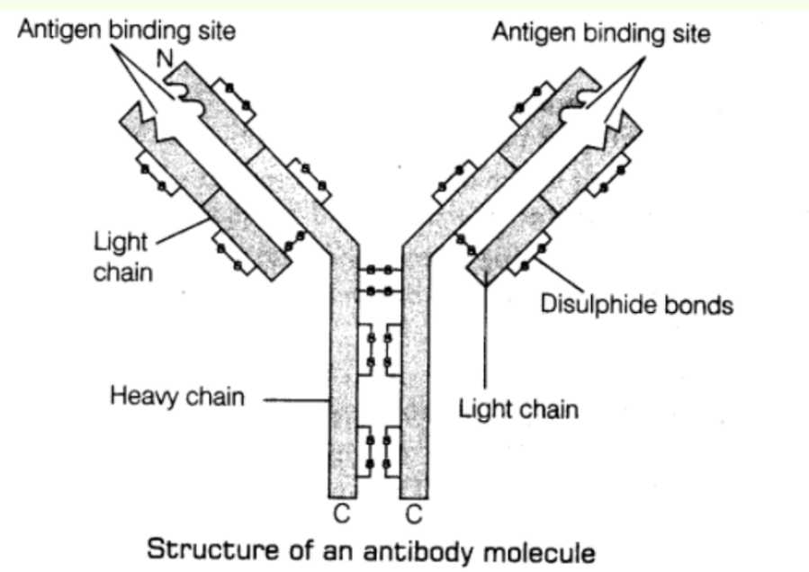

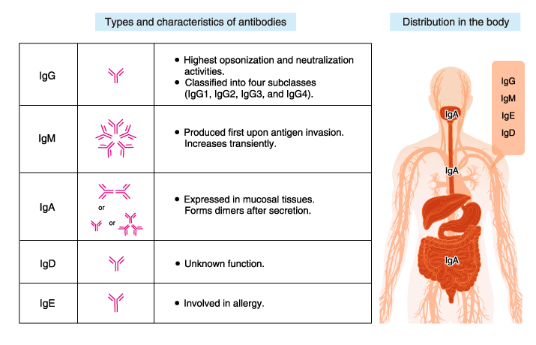

Stages of antibody-antigen reaction:
1. Agglutination
2. Precipitation
3. Complement activation
4. Neutralization
Clinical Applications:
Immunology has many clinical applications, including the development of vaccines, immunotherapy, and diagnostic tests. Vaccination is a type of immunization that involves the administration of the harmless live attenuated pathogen and the killed pathogen or a component of the pathogen to stimulate an immune response. The immune response provides protection against future infections with the same pathogen.
Immunotherapy involves the use of the immune system components to treat disease. This can include the administration of antibodies or other molecules that activate or inhibit the immune response. Immune checkpoint inhibitors are a type of immunotherapy that has revolutionized the treatment of cancer by allowing the immune system to recognize and kill cancer cells.
Diagnostic tests that detect antibodies or antigens can also be used to diagnose infections. For example, the enzyme-linked immunosorbent assay (ELISA) can detect the presence of antibodies against a specific pathogen in a patient's blood.
Global Immunization Programme:
In 1974, the World Health Organization (WHO) created the Expanded Programme on Immunization (EPI), a worldwide effort mobilized to help countries increase immunization coverage of basic childhood vaccines—diphtheria, measles, pertussis, polio, tetanus, and tuberculosis—using the third dose of diphtheria, tetanus, and pertussis (DTP3) as a measure of progress. Building on the historical success of smallpox eradication, the WHO sought to increase global vaccination coverage (which was <5% in 1974) among children younger than one year of age. However, one-fifth of the world's children, especially those who live in low-income countries, are not fully vaccinated with these traditional vaccines during their first year of life. The Global Vaccine Action Plan (GVAP) for 2011–2020 has established immunization coverage targets of at least 90% DTP3 coverage nationally and at least 80% DTP3 coverage in every district.² Countries can take a variety of actions to attain these targets, depending on their needs and the current status of their health system and immunization program.
WHO recommends that while vaccine supply is limited, the people at highest risk of COVID-19 are vaccinated first. This includes people who are more likely to get severe disease if they are infected (older persons and people with existing health conditions) and people who are more likely to be exposed to the virus (such as health workers). People who are pregnant have a higher risk of serious illness and preterm birth if they are infected with COVID-19, so WHO recommends that they are also prioritized for vaccination, once the first priority groups have been vaccinated.
World Immunization Week 2023 - 24 to 30 April
World Immunization Week, celebrated in the last week of April 2023, aims to highlight the collective action needed to protect people from vaccine-preventable diseases.
Under the theme of ‘The Big Catch-Up’, WHO is working with partners to accelerate rapid progress in countries to get back on track to ensure more people, particularly children, are protected from preventable diseases.
Conclusion:
Immunology is a complex and dynamic field that is essential for our understanding of the immune system and its role in health and disease. The immune system is composed of many different cells and molecules that work. Immunology is a critical branch of science that is constantly advancing and shaping our understanding of the immune system. Through the study of immunology, we have developed vaccines and therapies that have revolutionized the treatment of diseases such as cancer and infectious diseases. As we continue to expand our knowledge in this field, we can anticipate further breakthroughs in immunology that will have a significant impact on human health. Overall, the study of immunology is essential for our understanding of the immune system and its role in maintaining a healthy body.

