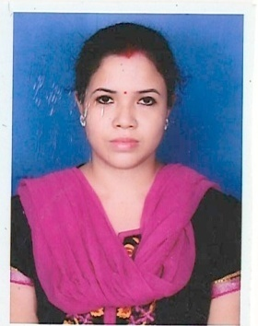
Curriculum Vitae
NAME: Sankari Malla Barman
SUBJECT: Geography
PHONE NO: (+91)-8013069443
EMAIL: sankaribarman02@gmail.com
PRESENT ADDRESS: 4/46 Netajinagar (Tollygung), Kolkata -700040
Career objective: To work for a recognized company which will make use of my skills and confidence, thereby giving me ample opportunity to explore my talents.
ACADEMIC QUALIFICATION:
DEGREE | INSTITUTE NAME | BOARD  NAME | YEAR  OF PASSOUT | PERCENTAGE
MADHYAMIK | NETAJINAGAR BALIKA VIDYAMANDIR | W.B.B.S.E | 2005 | 67.50%
HIGHER SECONDARY | JADAVPUR SAMMILITA BALIKA VIDYALAYA | W.B.C.H.S.E | 2007 | 63.80%
BACHELOR OF SCIENCE (B.SC) | NETAJINAGAR DAY COLLEGE | C.U | 2010 | 57.25%
MASTER OF SCIENCE (M.SC) | BALLYGUNGE  SCIENCE COLLEGE | C.U | 2012 | 64.70%
BACHELOR OF EDUCATION (B.ED) | VIVEKANANDA RAMKRISHNA MISSION B.ED COLLEGE | W.B.U.T.T.E.P.A | 2018 | 80.15%

TRAININGS:
- BASIC OF COMPUTER COURSE.
LANGUGES KNOWN:
- ENGLISH (Speaking, Writing)
- HINDI (Speaking, Writing)
- BENGALI (Speaking, Writing)
PERSONAL PROFILE:
Date of Birth : 2nd November, 1989
Father’s Name : LATE Kanai lal Malla Barman
Mother’s Name : Swapna Malla Barman
Marital Status : Married
Husband`s Name : Rajdeep Chatterjee
Nationality : Indian

Date: 20.07.2020 SIGNATURE: ------------------------------------
KOLKATA (SANKARI MALLA BARMAN)

